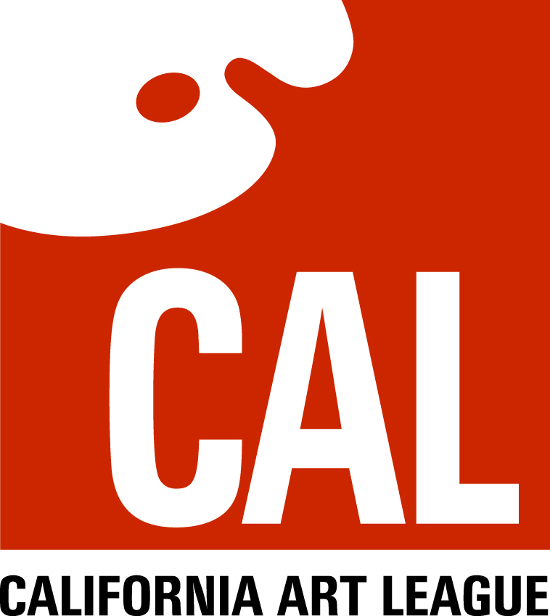
July 21, 2014
Dear CAL Associate member,
Once again, it’s time for CAL to offer an opportunity for all of our associate members to jury-in to become exhibiting members. This will be an in-person committee review of your work. (See next paragraph if you are a “long distance” member.) If your work is accepted by the jurying committee to be of sufficiently high level, your membership status will become elevated to that of exhibiting member. You will be able to enter all future CAL juried exhibits and be eligible for the various prizes and awards these exhibits offer. The timing of this jurying will allow newly elevated exhibiting members to enter our annual “Gold Medal” exhibit, which will have entry cut-off a week or so after the August 13th jurying.
The jurying process requires members to submit three works, all in the same medium and same genre, made in the last three years, for committee review. All media except photography are accepted. The committee will review the works for your competence in use of your medium, layout, design, proportion, balance and overall artistic quality. Works should be professional, gallery quality works. Frames are not required, but unframed canvases must have painted gallery-style edges. Paper work must be mounted. Extremely large or heavy works (like sculptures) or pieces from our “long distance” (out of the greater Los Angeles area) members may be submitted by paper or digital photos. Photos should be high resolution, 8”x 10” or larger that show enough detail to truly represent the work. Poor quality photos may not allow our committee to determine the quality of the art, so please only submit top quality photos.
(Everyone) If you have a larger body of work on a web site that is easy for the committee to view on-screen, the committee can also review it as part of the jurying process. This will be the first time we’ve tried reviewing a body of work on screen as part of the jurying-in process, but our group is very open to adopting current technology and we want to see what our members submit.
Delivery of work will be to Ken Ronney’s home, 7357 Hesperia Ave, Reseda, CA 91335, or Kronney@aol.com for submission of digital photos. Delivery date and time is Tuesday, August 12, from 4:00 to 6:00, or by appointment. The jurying-in review will be on the evening of August 13 by our board of directors. Pickup of works will be on Thursday, August 14, 4:00 to 6:00, or by appointment. We realize the delivery and pickup times may be difficult or impossible for some members, so don’t hesitate to set up a different time by calling me at 818 996-1630.
At pickup, you will be informed if you have been elevated to status of Exhibiting Member. Usually, about 7 of every 10 people who submit work for jurying are accepted as exhibiting members. If you aren’t accepted at this time, we strongly recommend you try again at the next opportunity later this year, with new or different works.
If you have any questions, don’t hesitate to contact me by phone at 818 996-1630, days or evenings, or by e-mail, at Kronney@aol.com.
Sincerely,
Ken Ronney
President,
California Art League

